Game Design Document

Fill up the Following document

1. Write the title of your project.

Sea run

1. What is the goal of the game?

To collect the coins and protect us from obstacles

1. Write a brief story of your game?

There is a girl who is the player. Some monsters are following her and she has to run to collect the coins and increase the score and protect herself from the obstacles coming in her journey

1. Which are the playing characters of this game?

* Playing characters are the ones which respond to the user based on the input from the user
* Cars, monkeys, dinos, wizards etc, are the playing characters in the game.

|  |  |  |
| --- | --- | --- |
| Number | Character Name | What can this character do? |
| 1 | Girl | To collect coins |
| 2 | monster | To eat the girl |
| 3 |  |  |
| 4 |  |  |
| 5 |  |  |
| 6 |  |  |
| 7 |  |  |
| 8 |  |  |

1. Which are the Non Playing Characters of this game?

* Non Playing characters are the ones which don't have an action or a behaviour when the user interacts with the game.
* Hurdles, stones, bananas, coins, etc are non playing characters in the game.

|  |  |  |
| --- | --- | --- |
| Number | Character Name | What can this character do? |
| 1 | coins | To increase the scores |
| 2 | Box | To make the player out |
| 3 |  |  |
| 4 |  |  |
| 5 |  |  |
| 6 |  |  |
| 7 |  |  |
| 8 |  |  |

Draw your imagination of this game. What does this game look like?

* Draw the game either on your computer or on paper,
* Add images of scenes of the game to show each of the playing and non-playing characters at least once.

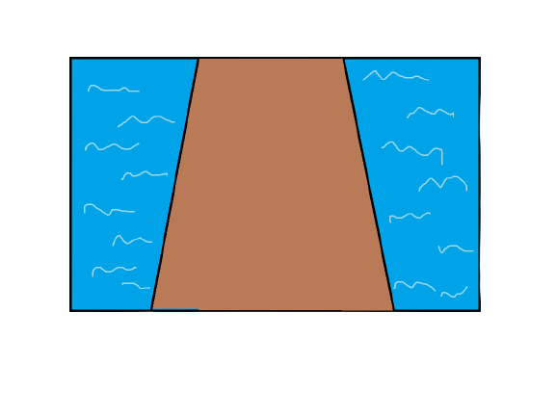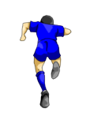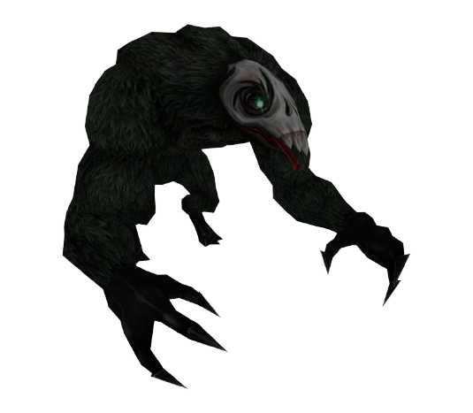

How do you plan to make your game engaging?

This is a infinite game. To make it engaging and interesting I have decided to design this like that as your score is increasing the speed of the coin and box will also increase